

**YOGA CENTER**

**Software Requirement Specification**

– HCM, May 2023 –

**Table of Contents**

I. Overview 3

1. Introduction 3

2. System Functions 4

3. Common Requirements 5

II. Functional Requirements 6

1. <<Feature Name 1>> 6

a. <<Function Name 1>> 6

b. <<Function Name 2>> 6

2. <<Feature Name 2>> 6

# I. Overview

## 1. Introduction

The Yoga Center System is a new software system that offers high-quality yoga and mindfulness content for users to practice at home. The target audience includes those who prefer practicing yoga at home. As well as the need to provide high-quality audio and video content, assumptions include basic knowledge of yoga, and dependencies include third-party payment integration, partnerships with experts, and data privacy standards.

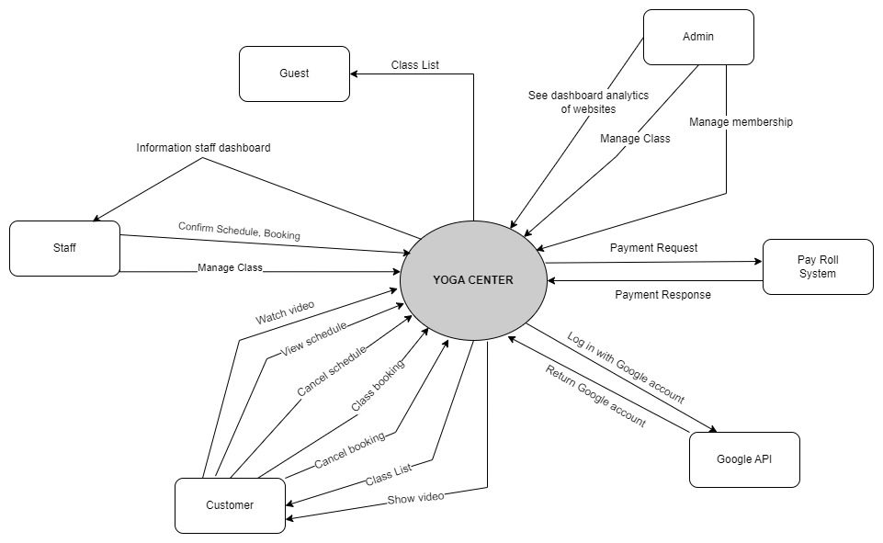

## 2. System Functions

#### a. Screen Flow

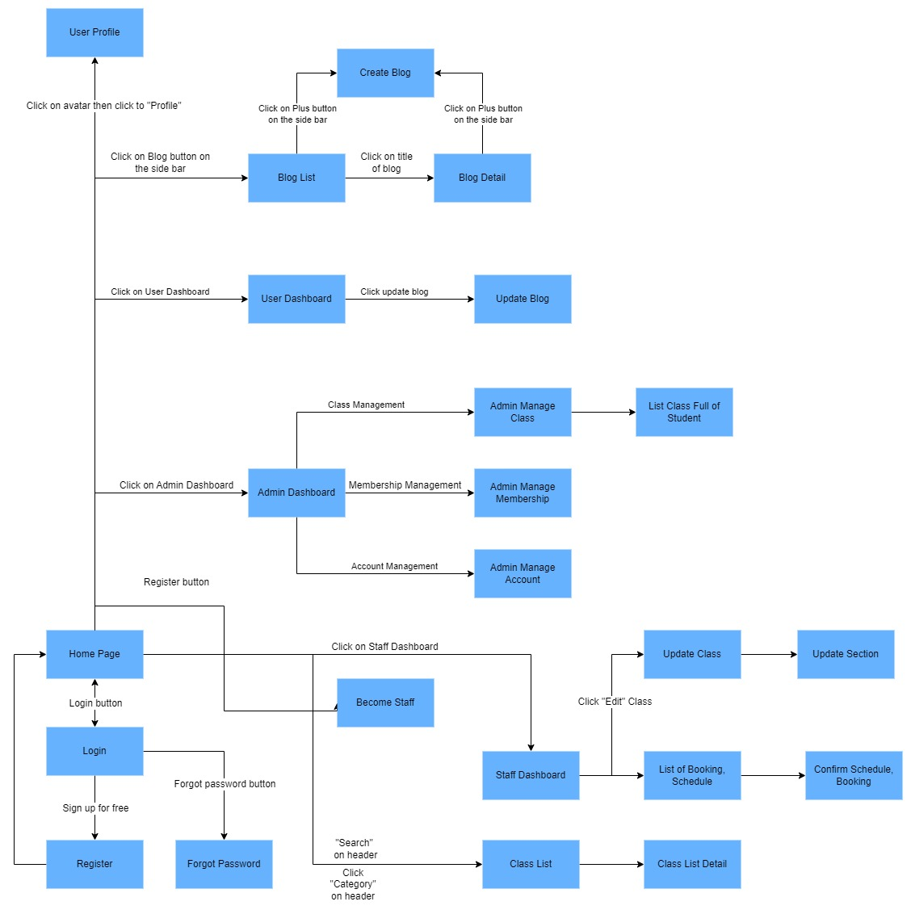

#### b. Screen Details

|  |  |  |  |
| --- | --- | --- | --- |
| **#** | **Feature** | **Screen** | **Description** |
| 1 | Login with Google | Login | User can log in this page with google account to access if their already have accounts. Three roles are available: admin, staff, and customer, each with its own dashboard and permissions. |
| 2 | Register | Register | This page is only for user want to create account to log in the system. |
| 3 | Reset Password | Forgot Password | This feature will send new password to their email address if email is verification. |
|  |  |  |  |
| 4 | Account Profile | Account Profile | Show general information of account like date of birth, country, region, phone number, email address, username. |
| 5 | Update Profile | Account Profile | Users can edit information of account like username, dob, phone number, ... |
| 6 | Account Change Password | Change Password | Change password is a feature when user want to change a new password for their account. |
| 7 | Account Authorization | Non-screen | Identify what user can access to system. |
| 8 | Home Page | Home Page | Show class, marketing class, categories class. |
| 9 | Class List | Home Page | List of all class in the home page. |
| 10 | Search Class | Home Page | Allow users to search class |
| 11 | Class Details | Class Details | Allow users view details of the course. |
| 12 | Class Booking | Class Details, Home Page | Allow users to booking the class and see the schedule to start learning. |
| 13 | User Dashboard | User Dashboard | Show all user class booking, schedule and progress of each class. |
| 14 | Class Video List | Class Watch | List all video of the class. |
| 15 | Post Video Comment | Class Watch | Allow user to comment into the video they are watching. |
| 16 | Update Class | Staff Dashboard | Allow staffs to update the courses they have created. |
| 17 | Disabled Class | Staff Dashboard | Allow staffs to disable the class they have created. |
| 18 | Staff Dashboard | Staff Dashboard | Allow the staff to see basic information about his or her class. |
| 19 | Staff manage their class | Staff Dashboard | Allow the staff to manage their class. |
| 20 | Favorite class | Home Page | Allow users to like the class. |
| 21 | Update blog | User dashboard | Allow users to update blogs. |
| 22 | Delete blog | Blog Detail | Allow users to delete blog. |
| 23 | Create blog | Blog Detail | Allow users to post a blog. |
| 24 | Blog Detail | Blog Detail | Allow users to see a detail blog. |
| 25 | Blog List | Blog List | Allow users to see all the blog. |
| 26 | Admin dashboard | Admin dashboard | Statistics web. |
| 27 | Staff information | Admin dashboard | Allow admin to see all information of staff. |
| 28 | Account management | Admin dashboard | Admin can management account. |
| 29 | Class management | Admin dashboard | Admin can management class. |
| 30 | Membership  management | Admin dashboard | Admin can management membership. |

#### c. User Authorization

|  |  |  |  |  |
| --- | --- | --- | --- | --- |
| **Screen** | **Guest** | **Customer** | **Staff** | **Admin** |
| <<Screen Login>> | X | X | X | X |
| Login with google account | X | X | X | X |
|  |  |  |  |  |
| <<Screen Register>> | X | X | X | X |
| Register account | X | X | X | X |
|  |  |  |  |  |
| <<Reset Password>> |  |  |  |  |
| Forgot Password | X | X | X | X |
|  |  |  |  |  |
| <<Screen Home>> | X | X | X | X |
| Home Page | X | X | X | X |
| Search Class | X | X | X | X |
| Class List | X | X | X | X |
| Class Booking |  | X | X | X |
| Favorite class |  | X | X | X |
|  |  |  |  |  |
| <<Screen Account Profile>> |  | X | X | X |
| Account Profile |  | X | X | X |
| Update Profile |  | X | X | X |
|  |  |  |  |  |
| <<Screen Class Detail>> |  | X | X | X |
| Class Details |  | X | X | X |
| Class Booking |  | X | X | X |
|  |  |  |  |  |
| <<Screen User Dashboard >> |  | X | X | X |
| User Dashboard |  | X | X | X |
| Update blog |  | X | X | X |
|  |  |  |  |  |
| <<Screen Blog List>> |  | X | X | X |
| Blog List |  | X | X | X |
|  |  |  |  |  |
| <<Blog Detail>> |  | X | X | X |
| Delete blog |  | X | X | X |
| Create blog |  | X | X | X |
| Blog Detail |  | X | X | X |
|  |  |  |  |  |
| <<Class Watch >> |  | X | X | X |
| Class Video List |  | X | X | X |
| Class Booking |  | X | X | X |
|  |  |  |  |  |
| <<Screen Staff Dashboard>> |  |  | X | X |
| Staff Dashboard |  |  | X | X |
| Staff manage their class |  |  | X | X |
| Disabled Class |  |  | X | X |
| Update Class |  |  | X | X |
|  |  |  |  |  |
| <<Screen Admin Dashboard>> |  |  |  | X |
| Admin dashboard |  |  |  | X |
| Staff information |  |  | X | X |
| Account management |  |  |  | X |
| Class management |  |  | X | X |
| Membership management |  |  |  | X |
| … |  |  |  |  |

#### d. Non-Screen Functions

|  |  |  |  |
| --- | --- | --- | --- |
| **#** | **Feature** | **System Function** | **Description** |
| 1 | User authorization | userAuthorization | Check the user if they are allow to enter the class or not. |
| 2 | Encode With SHA-256 | encodeSHA256 | Encode the password with SHA-256 to secure the password. |
| 3 | Class progress | classProgress | Calculate the course progress by tracking watched video the class. |
| 4 | Input validation | ipnutValidation | Valid user’s input. |

## 3. Common Requirements

* Create an online Yoga Center app for everyone.
* User can upload a new class.
* Main page should have favorite class and new class.
* Admin must approve new register staff.
* Admin must approve new class.
* Admin can promote and demote user roles.
* Staff should have a page for controlling the class.
* Users can check booking history
* Users can track on their schedule
* Users can update their information.
* Users must use google account to login.
* Users should able to cancel their booking.

# II. Functional Requirements

## 1. <<Feature Name 1>>

### a. <<Function Name 1>>

*[A function can be a screen or a non-screen function (listed in the part 5.1 above). In this part, you need to provide the details on the related function, focus on mentioning below information*

* *Function trigger: how this function is triggered (navigation path, a timing frequency, etc.*
* *Function description: actors/roles, purpose, interface, data processing, etc.*
* *Screen layout: mockup prototype of the screen, sample below is for Manage Products screen*

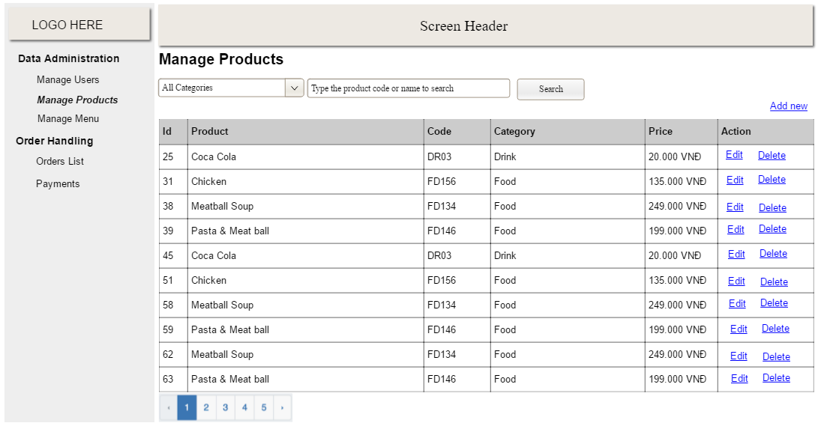

* *Function Details: provide explanation for the data, validation, business logics, functionalities (for both normal cases and abnormal cases), etc. of the function so that the reader can image how it work.*

*]*

### b. <<Function Name 2>>

…

## 2. <<Feature Name 2>>

…